

**LiveVault**

**Plugin Configuration Guide**

Contents

Supported Collection Types 2

Data Sources 2

Requirements 2

Network Ports 2

LiveVault Configuration Checklist 2

User Configuration & Bocada Setup 2

Bocada Setup 4

Server Properties 4

Field Definitions 4

Technical Support 5

# 

# Supported Collection Types

The plugin currently supports the following collection types from LiveVault servers:

|  |  |  |
| --- | --- | --- |
| **Collection Type** | **Supported** | **Description** |
| Backup | ✓ | Collects transactional details about backup, duplication and restore jobs. Example metrics include, start times, durations, bytes, files, errors etc. In Progress Jobs are also collected here. |
| Storage | ✓ | Collects point-in-time inventory information. Example metrics include, total recoverable gigabytes (storage), media volume count, media volume status, etc. |
| Policy |  | Collects and stores information on policy attributes, schedules, storage units, storage groups, storage lifecycle policies and clients. |

# Data Sources

The plugin relies on the following LiveVault data sources:

* REST API

# Requirements

The Bocada Data Collection Server must be able to connect to the LiveVault Server on the port(s) listed in the table below.

### **Network Ports**

|  |  |  |
| --- | --- | --- |
| **Service** | **Default Port** | **Note** |
| *­­HTTPS* | 443 | REST API connection through HTTPS |

# LiveVault Configuration Checklist

While detailed steps are included below, this is an overview of the steps to configure LiveVault collections on your Bocada Data Collection Server:

* Credentials for users with the required permissions have been obtained

### User Configuration & Bocada Setup

Bocada collects all data for which the supplied user credentials have access. Users can be configured in two ways, Partner-level or Customer-level data access.

#### Customer-ViewOnly

This data access should be used when reporting on multiple customers and is especially powerful with MSP configurations to automate customer data segregation.

When adding a LiveVault “Server” to Bocada, any name can be used, and it is recommended to include Customer identification if you need to segregate data by customer.

#### Partner-ViewOnly

This data access should be used when reporting on the entire environment using a single Bocada “Server”. Though it is possible that customer data can be segregated using this method, it is dependent on naming conventions at the policy or customer application levels.

# Bocada Setup

### Server Properties

Backup Server Properties determine how the plugin will interface with the LiveVault server and are managed through the Backup Servers view.

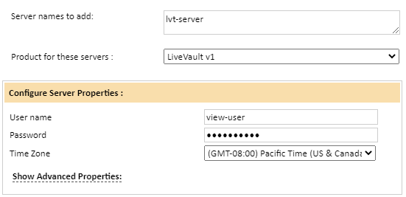

### Field Definitions

***Server name***

This field is not tied to any network name or IP address, and is not case sensitive. It is recommended that the name chosen is identifiable within the Bocada reporting.

#### User Name & Password

Enter the name and password for a LiveVault GUI user which could be Customer-ViewOnly or Partner-ViewOnly.

#### Time Zone

Select the time zone where LiveVault server resides. This setting defines how job times will be shifted when reporting across different time zones.

# 

# Technical Support

For technical support or a copy of our standard support agreement, please contact us.

**E-mail:** [support@bocada.com](mailto:support@bocada.com)

**Support Portal:** http: <https://bocada-support.force.com/s/>

**Phone:** +1-425-898-2400